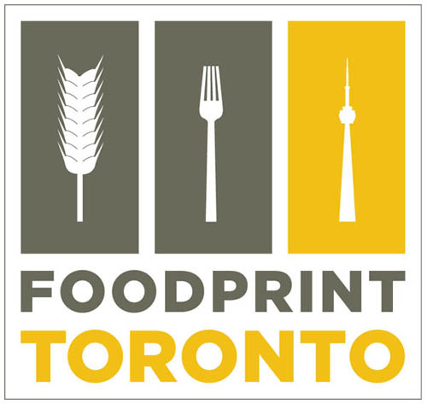

For further information or interview requests,
please contact:

Foodprint Project
Sarah Rich & Nicola Twilley
+1 310.876.2427
foodprintcity@gmail.com
www.foodprintproject.com
Twitter: @foodprintcity
#foodprintTO

FOR IMMEDIATE RELEASE
FOODPRINT TORONTO: Program Announced
Saturday, July 31, 2010: 12:30 – 5.00 p.m.
Artscape Wychwood Barns (map)

From an urban fruit forager to a Chippewa fisherman, Foodprint Toronto will bring together food producers and entrepreneurs in discussion with city policy-makers, activists, and some of Toronto’s most interesting architects, artists, historians, and critics.

SAN FRANCISCO & MONTREAL – July 26, 2010 – In just over a week, on Saturday, July 31, from 12:30 to 5:00 p.m., Foodprint Toronto co-curators Sarah Rich and Nicola Twilley wlll bring together a remarkable group of panelists for four back-to-back conversations that will generate fresh perspectives on the relationship between food and the city.

12:30 – 1:30 p.m.: Zoning Diet
How do zoning, policy, and economics shape Toronto’s food systems?
Jessica Duffin Wolfe, Barbara Emanuel, Pat Pessotto, Lola Sheppard
1:30 – 2:30 p.m.: Culinary Cartography
What can we learn when we map Toronto using food as the metric?
Laurel Atkinson, Mark Fram, Chris Hardwicke, Darren O’Donnell
2:30 – 3:00 p.m.: Break, with snacks and drinks generously provided by Steam Whistle, Ontario Natural Food Co-op, Akiwenzie Fish, Not Far From The Tree, and more.

3:00 – 4:00 p.m.: Edible Archaeology
How has today’s food culture in Toronto been shaped by social changes, economic fluctuations, and technological innovations throughout the city’s history?
Andrew Akiwenzie, Shawn Micallef, Rebecca O’Neill, Robert Wright
4:00 – 5:00 p.m.: Feast, Famine, and Other Scenarios
What are the opportunities and challenges of Toronto’s possible food futures?
Evan D. G. Fraser, John Knechtel, Kathryn Scharf, Michael Wolfson

The first panel of the day unites the co-author of the city’s newly adopted Food Connections strategy (Emanuel), with an architect whose research uses infrastructure as a lens through which to understand sites such as the Green Belt and the Ontario Food Terminal (Sheppard), the VP of Procurement at Longo’s grocery chain, and a journalist whose recent articles include an overview of the fight to change Toronto’s restrictive street vending laws (Duffin Wolfe). “Of course, policy, infrastructure, and economics are all vast subjects in and of themselves,” admits Twilley, the Zoning Diet panel moderator. “But by asking such a diverse group to comment on a handful of tangible but relatively unknown examples, I think we’ll offer our audience a genuinely eye-opening introduction to the hidden corsetry that shapes the city’s foodscape.”

Following on from that, Sarah Rich will ask her Culinary Cartography panelists to share what they have learned about Toronto and its residents as they map its fruit trees, redesign its ravines, go in search of its lost greenhouses, and ask children to act as restaurant critics on Queen St. West. Guest moderator Geoff Manaugh, of the popular architecture website BLDGBLOG, explains that he is expecting conversations on the Edible Archaeology panel to range from “tracing native and immigrant traditions within the Toronto food system, to shifting trends in restaurant design and school food.”

Foodprint Project co-founders Sarah Rich and Nicola Twilley will team up to lead the final conversation of the day, challenging their speakers to imagine the future of food in Toronto. A business specialist (Wolfson), community food activist (Scharf), agriculture and climate change researcher (Fraser), and visionary editor (Knechtel) will offer their insights into practical ways to scale up urban agriculture and re-integrate food processing throughout the city. They will also make more speculative suggestions as to how shrinking global reserves of fossil fuels and water might affect Toronto’s ability to feed its growing population over the next half-century and beyond.
Foodprint Toronto is open to the public (with seating for up to 400): admission is by donation ($5 suggested) at the door, with no RSVP required. It will also be available to view online at www.ustream.tv/channel/foodprint-toronto. It is curated by Sarah Rich and Nicola Twilley, and will take place on Saturday, July 31, from 12:30 to 5:00 pm. The program is being hosted by Artscape Wychwood Barns (601 Christie Street, Toronto, ON, M6G 4C7) and is made possible by generous support from Virgin America, Gladstone Hotel, Steam Whistle, Ontario Natural Food Co-op, Akiwenzie’s Fish, Not Far From The Tree, and more.
For press requests, reserved seating, and more information, including panelist bios, media clips, and footage from previous events, contact foodprintcity@gmail.com or visit the event website at www.foodprintproject.com. An earlier press release with comments from Twilley and Rich on the origins of the Foodprint Project and the timeliness of Foodprint Toronto is available for download here: http://www.foodprintproject.com/press/
###
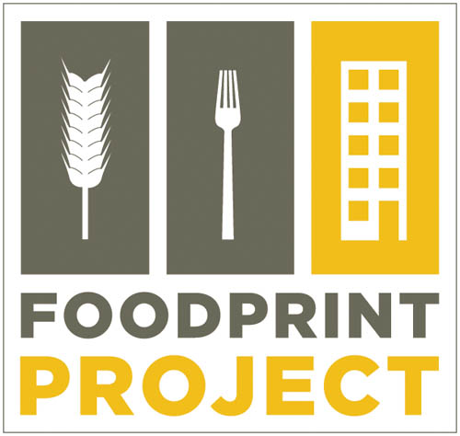
About Foodprint Project
Foodprint Project is an exploration of the ways food and cities give shape to one another. Founded by Nicola Twilley and Sarah Rich, the project is punctuated by a series of international events, beginning with Foodprint NYC in February 2010, and followed by Foodprint Toronto (forthcoming, July 2010)
<foodprintproject.com>

Sarah Rich is a writer and content strategist specializing in new media, design, food and sustainability. She is a former senior editor at Dwell magazine, co-author of the book Worldchanging: A User's Guide for the 21st Century, and most recently a co-founder of 48 Hour Magazine.
<sarahrich.com>

Nicola Twilley is a writer and the author of Edible Geography. With Geoff Manaugh, she is the co-founder of Future Plural and the co-curator of Landscapes of Quarantine, an exhibition on display at New York City’s Storefront for Art and Architecture during March and April, 2010.
<ediblegeography.com>

Foodprint Project is a Future Plural event.



About Future Plural
Future Plural is an independent research lab, non-academic academy, and umbrella for creative collaboration. Founded by Geoff Manaugh and Nicola Twilley in 2009, its activities include the production of seminars, studios, events, publications, installations, and exhibitions that investigate spatial questions and propose intriguing responses.

Foodprint Toronto is made possible in part through the generous support of Virgin America and the Gladstone Hotel.
Foodprint Toronto is grateful to be hosted by Artscape Wychwood Barns.


Refreshments, snacks and gift cards have been generously donated by Fresh Restaurants, Ontario Natural Food Co-op, Steam Whistle Brewery, Akiwenzie’s Fish & More, Not Far From The Tree, and more.





Videography is kindly provided by Kevin Lisoy (kevinlisoy.com). Book sales are kindly provided by Swipe Books.

###

